Solid State is one of the states of matter. Solids generally exhibit certain characteristics that set them apart from liquids and gases. For example, they have the ability to resist any force that is applied to its surface. However, the solid-state of compounds largely depends on the properties of atoms, such as their arrangement and the forces acting between them

Types of Solid States
Based on the arrangement of constituent particles, solids are classified into two-state types:
- Crystalline Solids
- Amorphous Solids
1. Crystalline
Has a regular, repeating arrangement of atoms or molecules. Crystalline solids have a defined shape, pattern, and long-range order. They have well-defined edges and faces, diffract x-rays, and tend to have sharp melting points. Examples of crystalline solids include salt, diamond, copper, and baking soda.
2. Amorphous
Lacks long-range order and has a disordered atomic structure. Amorphous solids do not have a well-defined melting point. They have irregular or curved surfaces, do not give well-resolved x-ray diffraction patterns, and melt over a wide range of temperatures. Examples of amorphous solids include rubber, plastic, and gels. Glass is an important amorphous solid.

Objectivity of Study:
Silicon is a tetravalent atom, meaning it has four valence electrons. However, when silicon is doped with either trivalent or pentavalent atoms, it can be used to create n-type or p-type semiconductors:
The main difference between a pentavalent atom and a trivalent atom is the number of valence electrons they have:
- Pentavalent atom: Has five valence electrons. Some examples of pentavalent atoms include: Arsenic (As), Phosphorus (P), Antimony (Sb), and Bismuth (Bi).
- Trivalent atom: Has three valence electrons. Some examples of trivalent atoms include: Indium (In), Aluminium (Al), and Boron (B).

Pentavalent and trivalent atoms are used as dopants to create N-type and P-type semiconductor materials. When mixed with semiconductors, these atoms create a defect in the lattice structure. The presence of free charge carriers in semiconductors increases their conductivity, which means they can carry electric charge and current more easily.

Crystalline Solid State
Crystalline solids are those that have a typical geometry. In such types of solids, there are definite arrangements of particles (atoms, molecules or ions ) throughout the 3-dimensional network of a crystal in a long-range order. Examples include Sodium Chloride, Quartz, Diamond, etc.
Properties of Crystalline Solids
- Crystalline solids have a sharp melting point and start melting when it reaches a particular temperature.
- The shape of crystalline solids is definite and has typical arrangements of particles.
- They show cleavage property, i.e., when they are cut with the edge of a sharp tool, they split into two pieces, and the newly generated surfaces are smooth and plain.
- They have definite heat of fusion (amount of energy needed to melt a given mass of solid at its melting point).
- Crystalline solids are anisotropic, which means their physical properties, like electrical resistance or refractive index, show different values when they are measured along with different directions in the same crystal.
- Crystalline solids are true solids.

Types of Crystalline Solids
On the basis of the nature of intermolecular forces or chemical bonding, crystalline solids are further classified into four categories. They are as follows:
- Molecular solids
- Ionic solids
- Metallic solids
- Covalent solids

Amorphous Solid State
Amorphous solid-state comprises those solids which have the property of rigidity and incompressibility but to a certain extent. They do not have a definite geometrical form or long range of order. Examples include glass, rubber, plastic, etc.
Properties of Amorphous Solids
- Amorphous solids are gradually softened over a range of temperatures, and they can be moulded into different shapes on heating.
- Amorphous solids are pseudo-solids or supercooled liquids, which means they have a tendency to flow very slowly. If you observe the glass pans, which are fixed to windows of old buildings, they are found to be slightly thicker from the bottom than at the top.
- Amorphous solids have irregular shapes. i.e., their constituent particles do not have definite geometry of arrangements.
- When amorphous solids are cut with a sharp edge tool, they form pieces with irregular surfaces.
- Amorphous solids do not have definite heat of fusion due to the irregular arrangement of the particles.
- Amorphous solids are isotropic in nature, which means the value of any physical property would be the same along any direction because of the irregular arrangement of particles.

Amorphous Solids Uses
Amorphous silicon, which is one of the best photovoltaic materials, converts sunlight into electricity.
CRYSTAL: Translationally periodic arrangement of ATOMS in space. LATTICE: Translationally periodic arrangement of POINTS in space. BASIS (or MOTIF): An atom or a group of atoms associated with each lattice point in crystal. LATTICE of a crystal tells how to repeat (the periodicity of the crystal).
In a crystal, basis, lattice, and crystal structure are all related to the arrangement of atoms, molecules, or ions into it.
- Basis: A group of atoms, molecules, or ions that are identical in arrangement, orientation, and composition. The basis can be different for different crystals. For example, copper and sodium crystals have a basis of single atoms, while NaCl has a diatomic basis.
- Lattice: An array of points that repeats periodically in three dimensions.
- Crystal structure: The arrangement of atoms, molecules, or ions in a crystal. It's formed by associating each lattice point with the basis.
A unit cell is a small group of the repeating pattern of the atomic structure. It's the building block of the crystal structure and explains the entire structure and symmetry.
The ‘crystal lattice’ is the pattern formed by the points and used to represent the positions of these repeating structural elements. The periodic structure of an ideal crystal is most easily described by a lattice. The crystal lattice is the array of points at the corners of all the unit cells in the crystal structure.

What is Crystal Lattice?
The crystal lattice is the symmetrical three-dimensional structural arrangements of atoms, ions or molecules (constituent particle) inside a crystalline solid as points. It can be defined as the geometrical arrangement of the atoms, ions or molecules of the crystalline solid as points in space.

Crystal Lattice and Unit Cell
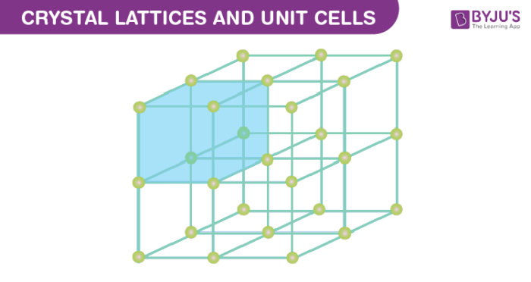

Characteristics of Crystal Lattice
- In a crystal lattice, each atom, molecule or ions (constituent particle) is represented by a single point.
- These points are called lattice site or lattice point.
- Lattice sites or points are together joined by a straight line in a crystal lattice.
- When we connect these straight lines we can get a three-dimensional view of the structure. This 3D arrangement is called Crystal Lattice also known as Bravais Lattices.

Unit Cell
Unit Cell is the smallest part (portion) of a crystal lattice. It is the simplest repeating unit in a crystal structure. The entire lattice is generated by the repetition of the unit cell in different directions.

1. Parameters of a Unit Cell
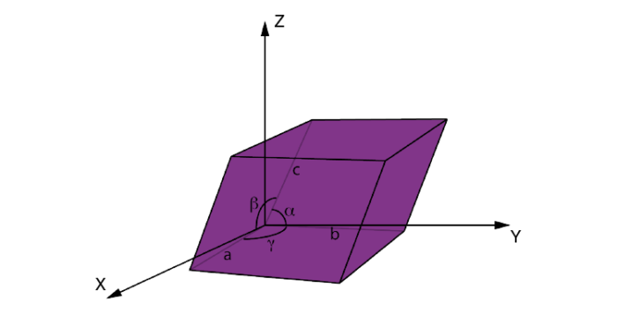
There are six parameters of a unit cell. These are the 3 edges which are a, b, c and the angles between the edges which are α, β, γ. The edges of a unit cell may be or may not be perpendicular to each other.

2. Types of Unit Cell

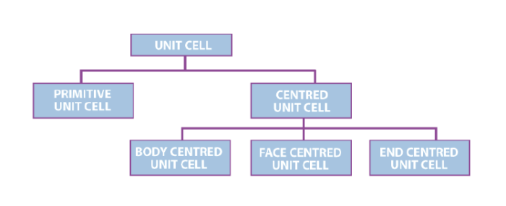

1. Primitive Unit Cells
When the constituent particles occupy only the corner positions, it is known as Primitive Unit Cells. A primitive cell is formed by the constituent particles when the effective number of atoms of the unit cell is one.

2. Centred Unit Cells
When the constituent particles occupy other positions in addition to those at corners, it is known as Centred Unit Cell. There are 3 types of Centred Unit Cells:
- Body Centred: When the constituent particle at the centre of the body, it is known as Body Centred Unit cell.
- Face Centred: When the constituent particle present at the centre of each face, it is known as Face Centred Unit cell.
- End Centred: When the constituent particle present at the centre of two opposite faces, it is known as an End Centred Unit cell.

